**LAB 1 – CHAPTER 1**

1. Now that you are familiar with the basic elements used on every web page. It is your turn to create your first web page.

Create a Folder

To create a new folder on a Mac:

1. In the folder, go to location where you will like to create the new folder.
2. Choose File>New Folder. An untitled folder is created.
3. To rename the folder with a new name: select the folder and click on the current name. Type a name for the folder and press the Return key.

To create a Folder with windows:

1. Right click on the Start Button and select File Explorer. Then, navigate to the location where you will like to create the new folder, such as Documents, your C: drive, or an external USB drive.
2. Select the Home tab. Select New Folder.
3. To rename the new folder: right-click on it, select Rename from the context-sensitive menu, type the new name, and press the Enter key.

Now that you are ready to create your first web page. Launch Notepad or another text editor. Type the following code.

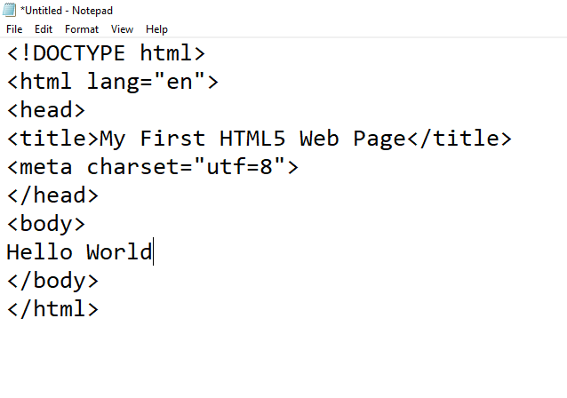

Your web source code displayed in Notepad.

Save Your File.

Web pages use either an .htm or .html file extension. A common file name for the home page of a website is index.html or index.htm. The web pages in the textbook use the .html file extension.

You will save your file with the name of index.html.

1. Display your file in Notepad or another text editor.
2. Select File from the menu bar, and then select Save As.
3. The Save As dialog box appears as shown below as an example, type the file name.
4. Click the Save button.

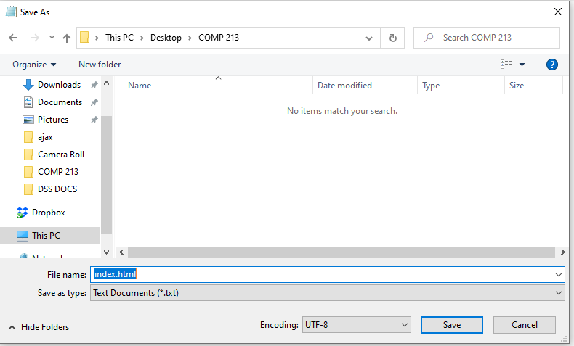

Save and name your file.

Test Your Page

There are two ways to test your page:

1. In Windows Explorer(windows) or the Finder(Mac), navigate to your index.html file. Double click index.html. The default browser will launch and display your index.html page.
2. Launch a web browser. Select File>Open, and navigate to your index.html file. Double click index.html and click OK. The browser will display your index.html page.

If you are using Microsoft Edge, your page should look similar to the one shown below.

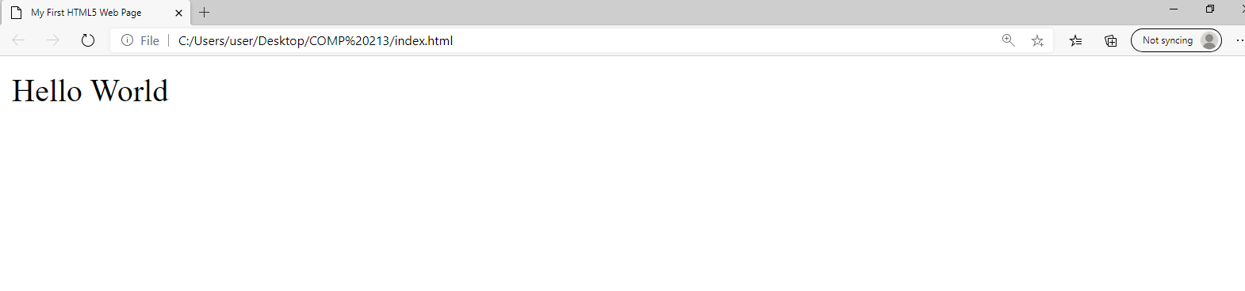

1. A blog or web log, is a journal that is available on the Web-it’s a frequently updated page with a chronological list of ideas and links. Blog topics range from political journals to technical information to personal diaries. It’s up to the person, called a blogger, who creates and maintains the blog.

Create a blog to document experiences as you study web design, visit one of the many sites that offer free blogs, such as <http://blogger.com>, <http://tumblr.com>. Or <http://www.wordpress.com>. Follow their instructions to establish your blog. Your blog could be a place to note websites that you find useful or interesting. You might report on websites that contain useful web design resources. You might describe sites that have interesting features, such as compelling graphics or easy-to-use navigation. Write a few sentences about the site that you find intriguing. After you begin to develop your sites, you could include the URLs and reasons for your design decisions. Share this blog with your fellow students and friends.